**Assignment(1)**

**Class:BBA-II(Sem-III)**

**Subject: : Principle of Human Resource Management**

**Topics:**Difference between induction and orientation ,Separation and benefits of separation

**Submitted To:**

Ashu Garg

Prof.of Management Department

**Ques1:Differenec between induction and orientation?**

**Ans.**

|  |  |
| --- | --- |
| **Induction** | **Orientation** |
| Introduces new employees to the company and its culture | Introduces new employees to the specific job and its requirements |
| Covers company history, values, mission, and goals | Covers job duties, expectations, policies, and procedures |
| Often done before the employee starts working | Often done on the first day of work |
| Can be done in a group or individually | Can be done in a group or individually |
| Can take several days or weeks to complete | Typically shorter and more focused |
| May include a tour of the facility | May include a tour of the specific department or work area |
| Can include training on company systems and processes | Can include training on specific job-related skills and tools |
| Facilitated by HR or a dedicated induction team | Facilitated by the employee's manager or a designated supervisor |

**Ques2:What is Separation?Describe benefits of separation?**

**Ans.**  **Employee Separation is the discontinuation of his employment contract with the company**. The termination of employees services can be either Voluntary or Involuntary. This can take the form of Retirement, Resignation, Discharge, Layoff, etc.

The companies and employees must specify valid reasons behind their separation. **The process may be upsetting for both, company and its employees**.

Hence, the employee separations should be well **planned**and**reasonable**. One must have a good experience post separation. As employees feedback builds the company’s image among prospecting candidates.

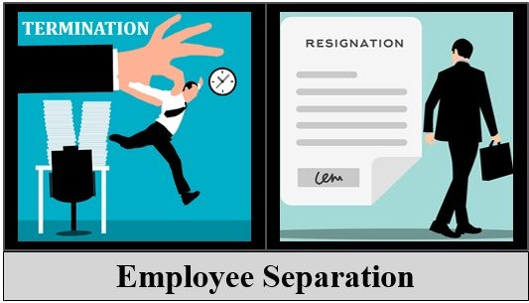

The employer should provide the required guidance to employees. The firms may conduct discussions and counselling sessions during separation.

[Exit Interviews](https://theinvestorsbook.com/exit-interview.html) of the separated employees are conducted. It helps to gather in-depth information about companies strengths and weaknesses.

**Employee Separation Process**

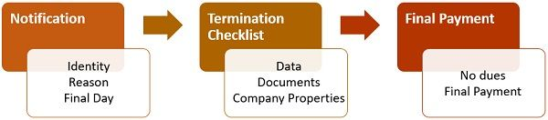

1. **Notification**: Both the company and the employee may send a notification to the HR department. The notification addresses the request or decisions about separation.  
   It specifies the following details:
   * Identity of the employee
   * A valid reason for separation
   * The final day of work
2. **Termination Checklist**: The manager must collect data, documents, and properties from the employee. He must complete and submit the termination checklist.  
   The manager handovers the collected stuff to the respective departments. This process takes place on the employee’s final working day.
3. **Final Payment**: Employee submits no dues to the finance department, after completing the necessary documentation.  
   Thereafter, the finance department will disburse the final payment to the employee.

### Benefits of Employee Separation

Separation is not necessarily a negative process. Besides it may benefit organization and employees in following ways:

To Organizations

* It enables a reduction in labour costs
* Replacement of the poor performers
* It increases opportunities for diversification and enhancement
* New recruits bring synergy within the organization
* Results in a disciplined work environment
* Reshape organization into the right size

To Employees

* Better career opportunities
* Get away from a troublesome workplace
* Enjoy benefits associated with retirement schemes